**Exercise 7.**

Introduction to Multisim

Table of Contents

List of Figures 1

Abstract 3

Part 1: Examine Active Filter in NI MULTISIM Program 4

Part 2: Design and Analyze of Active Filters 11

Part 3: Homework 14

# List of Figures

Figure 1 Example of active filter with attached power sources and the generator and the oscilloscope. 4

Figure 2 DC Operating Point Analysis Settings. 4

Figure 3 Results 4

Figure 4 Markers. 5

Figure 5 Output of filter 5

Figure 6 Closer view. 6

Figure 7 Cut Off Frequencies 6

Figure 8 E12 Circuit Update 6

Figure 9 E12 Tolerances 7

Figure 10 AC Sweep Param. 7

Figure 11 Output. 7

Figure 12 Output of Analysis (AC) 8

Figure 13 AC Analysis Measurement. 8

Figure 14 Capacitance Sweep 9

Figure 15 Temperature Analysis 9

Figure 16 Temp Cut-off 10

Figure 17 WC Analysis 10

Figure 18 Filter Specifications 11

Figure 19 Filter Design 11

Figure 20 Output 12

Figure 21 AC Analysis 12

Figure 22 Design Assumptions. 13

Figure 23 Sallen Key Circuit Band Pass 14

Figure 24 AC Analysis 14

Figure 25 Oscilloscope Output 15

Figure 26 Low Pass Filter 15

Figure 27 AC Analysis Output 16

Figure 28 Oscilloscope Output. 16

Figure 29 High Pass Filter Design 17

Figure 30 AC Analysis 17

# Abstract

The aims of this laboratory exercise were to learn the basics of using NI Multisim 10 simulation program through the testing of active filters.

# Part 1: Examine Active Filter in NI MULTISIM Program

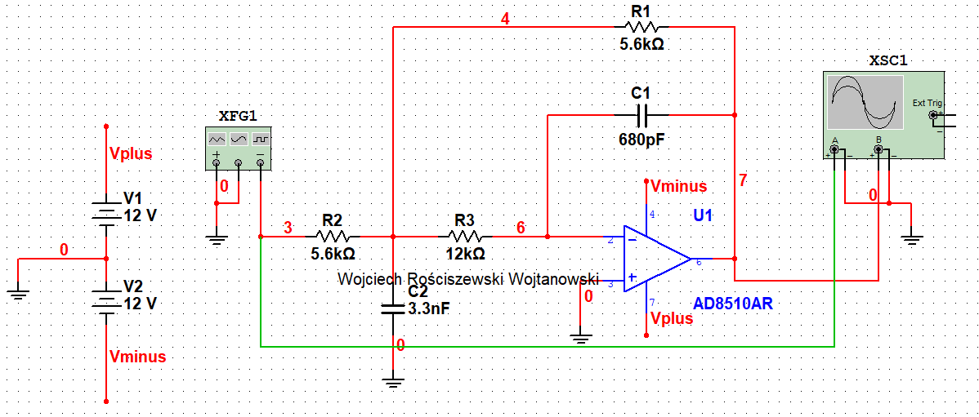

Figure 1 Example of active filter with attached power sources and the generator and the oscilloscope.

The task is to design a filter circuit in this Multisim software. We must first start off with setting the correct tolerance for passive components such as the capacitors and resistors. Below please find the new parameters of these passive components to be entered into the simulator.

* capacitors 10%,
* resistors E12 - tolerance of 10%, temp. co. 1000 ppm/°C (for carbon resistor),
* resistors E48 - tolerance of 0.5%, temp. co. 50 ppm /° C (for metallic resistor).

Below we will test the DC operating point in order to pre-determine the correct connections of the voltage source.

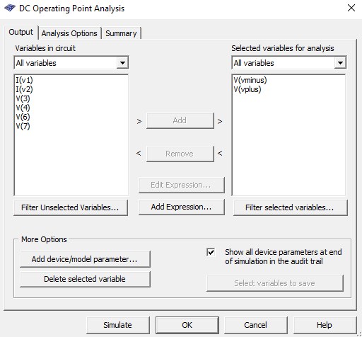

Figure 2 DC Operating Point Analysis Settings.

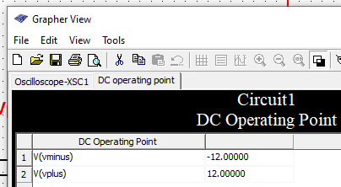

Figure 3 Results

Another method to confirm if the circuit or some specific component parameters should be visible we can insert probes to see these values as in the figure below.

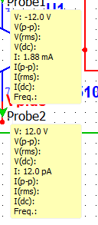

Figure 4 Markers.

In the below please see the output of the system.

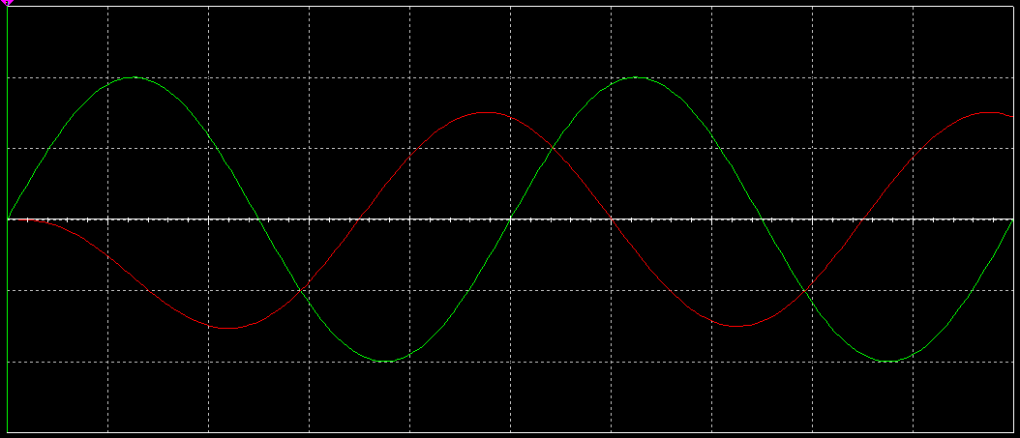

Figure 5 Output of filter

As we can see we have two signals, one is the original second is the filtered signal. Our simulated circuit functions correctly. Below find the close up of this.

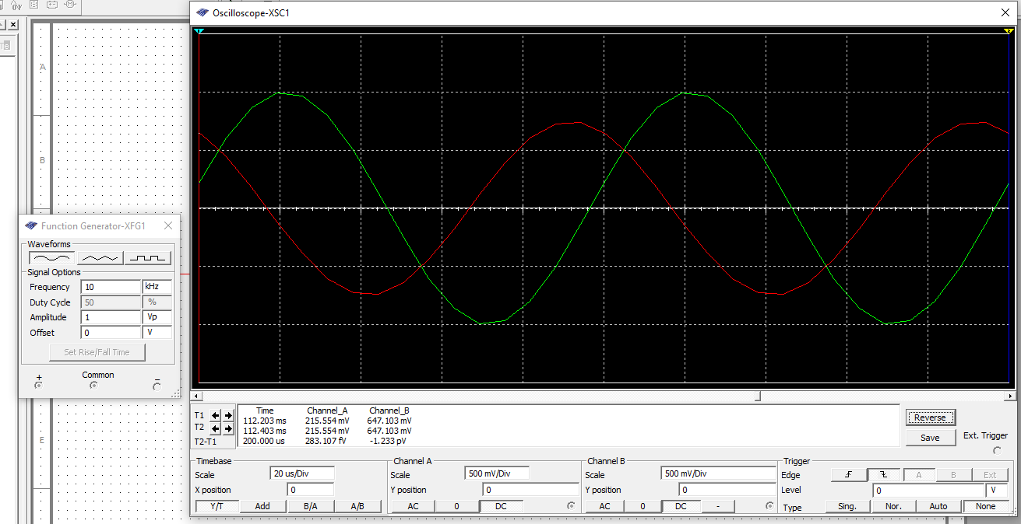

Figure 6 Closer view.

See that we have a 10kHz input signal. We now must find the center freq. and according to the cursors T2-T1 =26.5 which is around 37.7kHz. This means we can calculate Q factor (Q=f0/f1+f2) so we obtain Q=37.7kHz/12.2kHz+9.2kHz=1.8.



Figure 7 Cut Off Frequencies

However, please note that this is not the correct method to do this. Here I demonstrated that we can theoretically do this if we have no other option however we were quite close to the original result. Please see in the example of AC sweep to see how to analyze the 3db drop correctly using our provided frequency range instead of doing basic theoretical calculations.

For the next part we will modify the tolerances and the types of resistors used in this circuit so that we can see how they affect the overall performance of the circuit. Below please find the slightly modified circuit with the different tolerances applied.

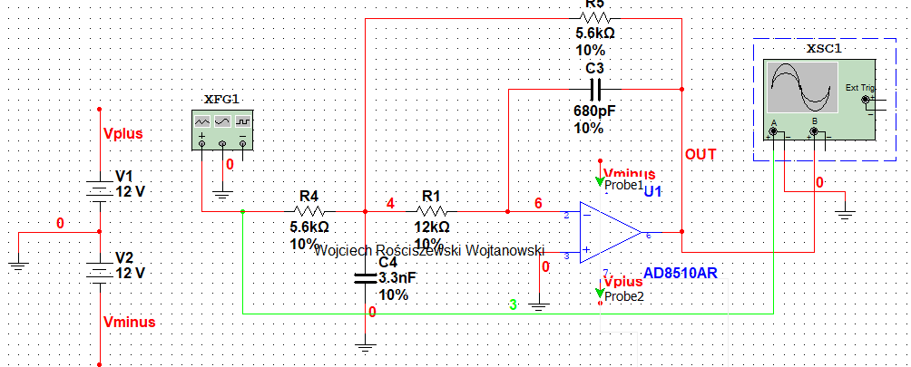

Figure 8 E12 Circuit Update

Please see the output.

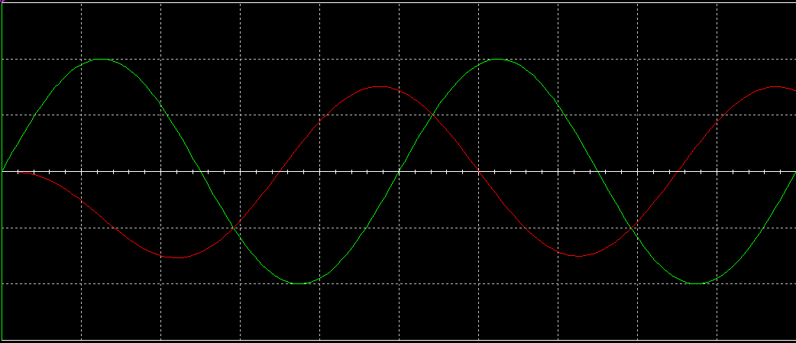

Figure 9 E12 Tolerances

As we can see that the circuit is affected very minimally, with the naked eye we cannot see a difference between the two graphs however if we zoom very small differences can be noticed but note these are extremely small.

Next, we must analyze the filter using the AC analysis sweep function. Please see in the below settings used for this.

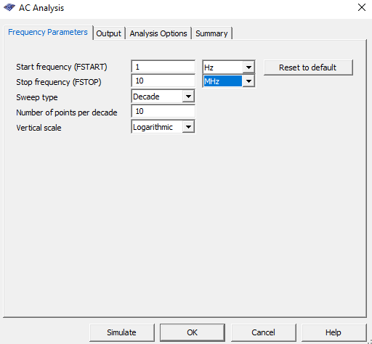

Figure AC Sweep Param.

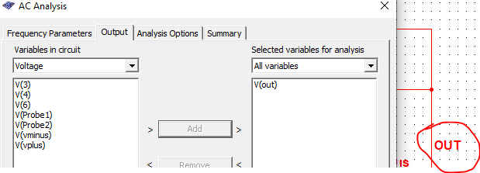

Figure 11 Output.

In the below please see the output AC Analysis of our AC Sweep.

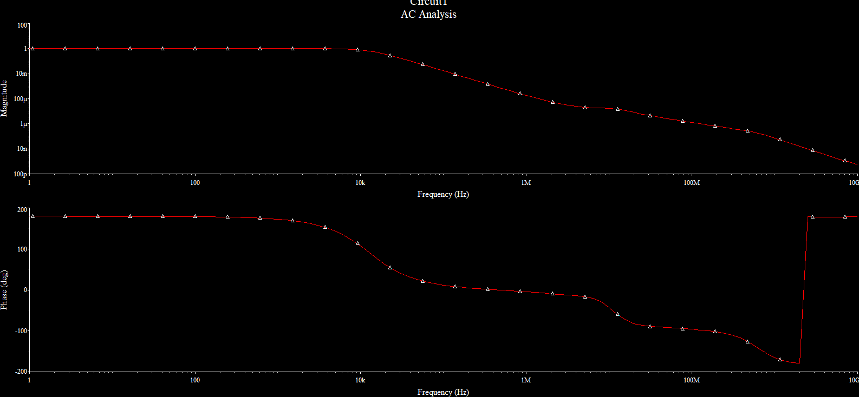

Figure 12 Output of Analysis (AC)

When we measure the .7 mark we will obtain the results presented in the figure below. Please see that our cut-off is at 11kHz.

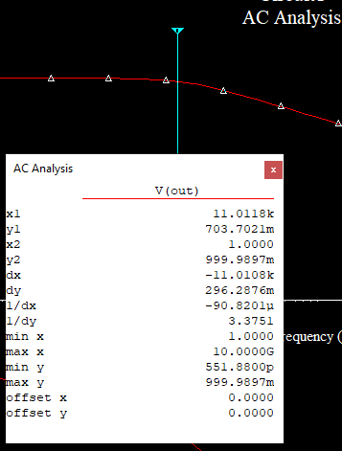

Figure 13 AC Analysis Measurement.

Below please see the parameter sweep for capacitance values.

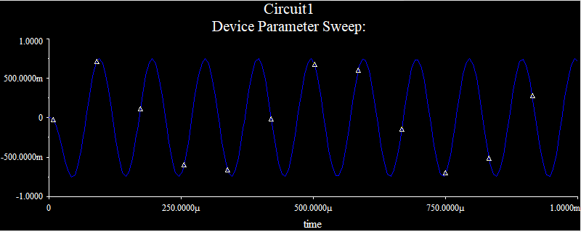

Figure 14 Capacitance Sweep

We see a full sinusoidal shape of our device parameters.

We will now alter the changes of temperature from -20 to 120 celcius using the temperature sweep analysis.

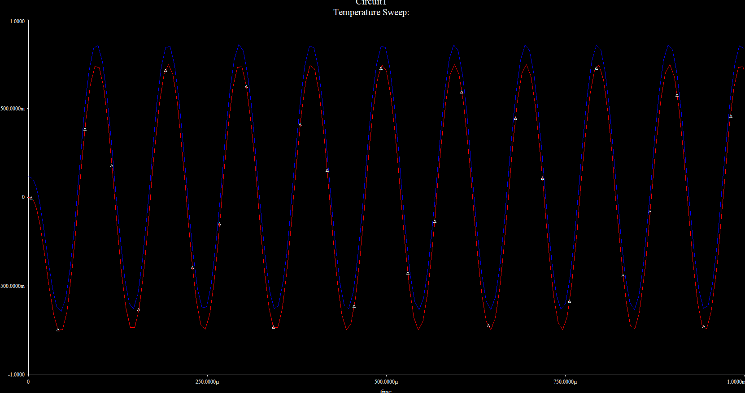

Figure 15 Temperature Analysis

We see that our signal is very different than the input signal, in regards to the curving, we have different not only offset of our output signal to input signal as well as the curving of the peaks!

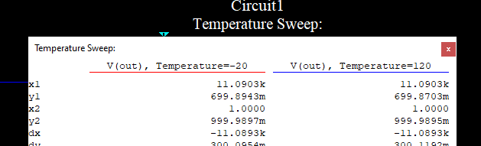

Figure 16 Temp Cut-off

In the above figure please see that out cut off frequency is the same as previously.

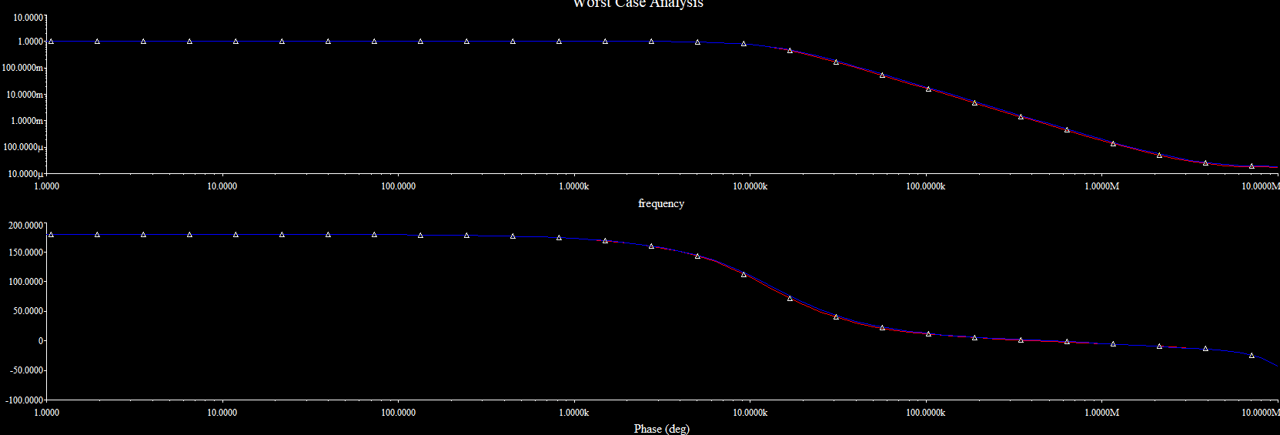

Figure 17 WC Analysis

In the above please see the worst-case analysis, using the cut off frequency provided, by checking we see that the WC cut off is at 11kHz also.

# Part 2: Design and Analyze of Active Filters

For this part of the exercise we will design an active filter for audio frequencies with the following parameters:

* band-pass,
* gain: 1 V/V,
* filter order: 4.
* filter response: Butterworth
* select multiple-feedback (MFB) circuit implementation
* design the filter, assuming the values of E12 series resistors (1%) and capacitors from the E48 series (5%).

To help understand how to build such filter we will use the following source online filter design page: <https://tools.analog.com/en/filterwizard/>.

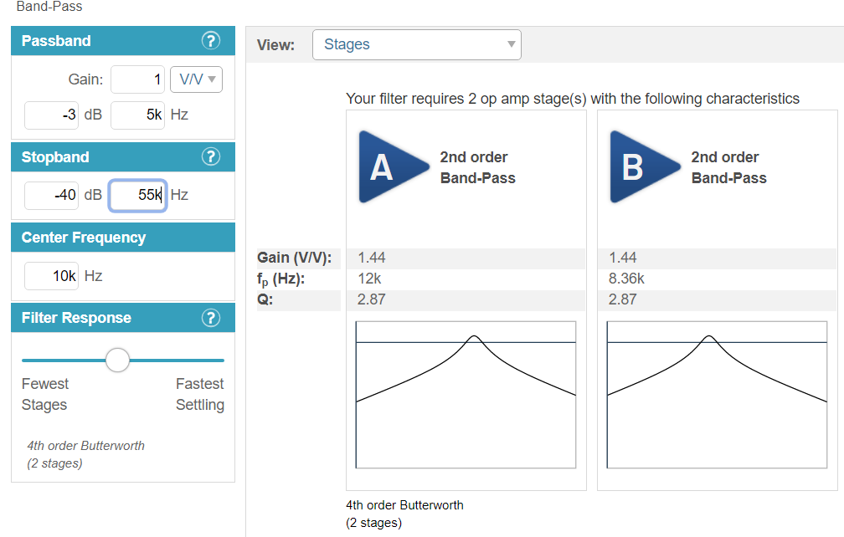

Figure Filter Specifications

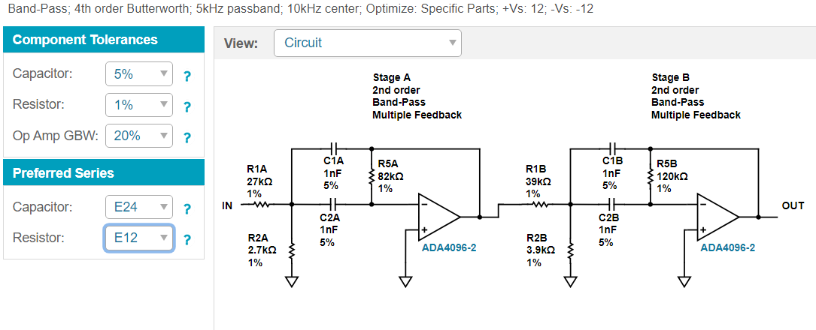

Figure 19 Filter Design

In the below please see the two-channel view of the oscilloscope. See that the green line is the oscilloscope before filter signal and the red is the filtered signal. Green is for reference we see that the filter filters. See conclusion below.

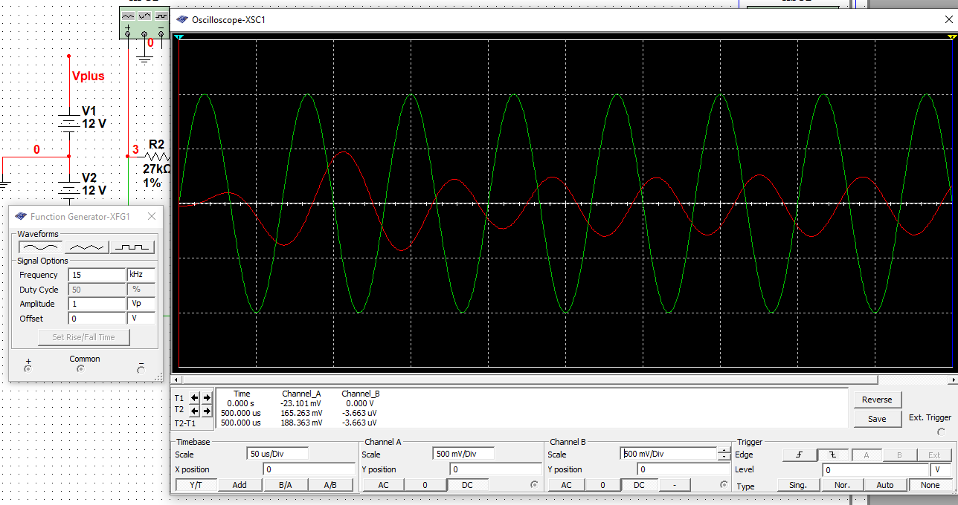

Figure 20 Output

As we can see in the plot characteristic above our designed filter works! Meaning the filter filters the 15kHz input frequency with only 5kHz.

Below please find the AC analysis of our system.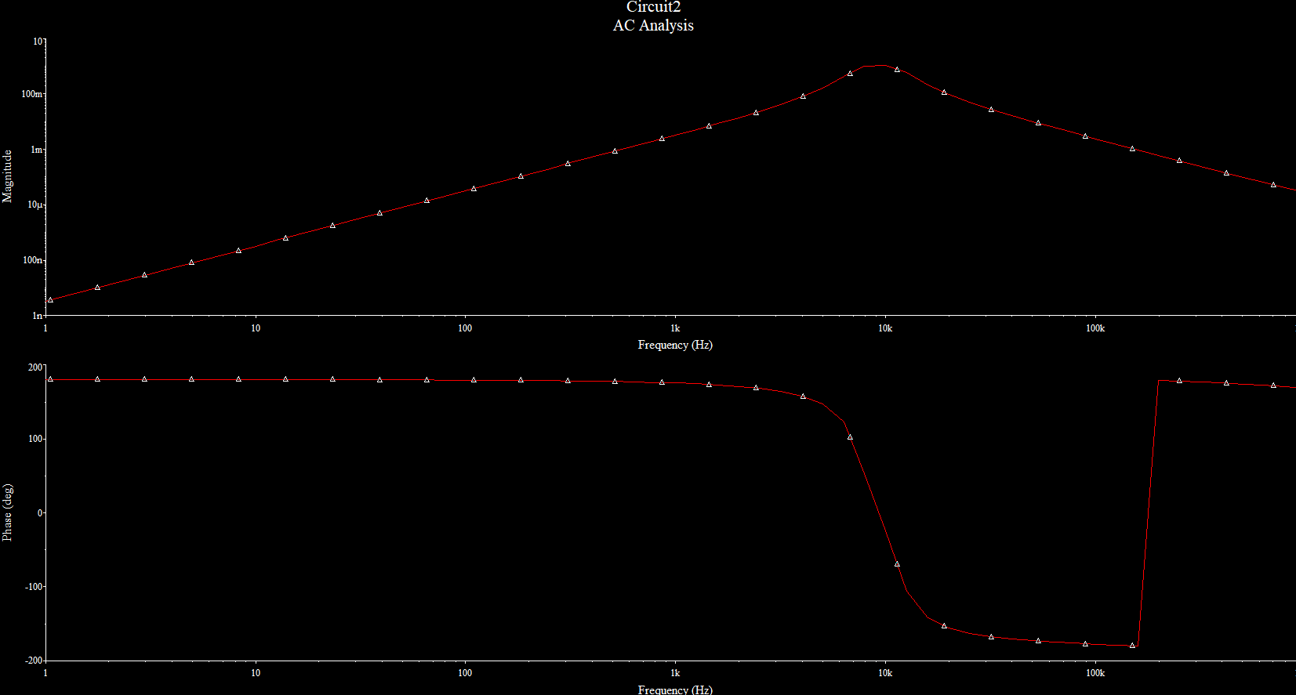

Figure 21 AC Analysis

For reference please see the below screengrab presenting the determined characteristic with our design assumption.

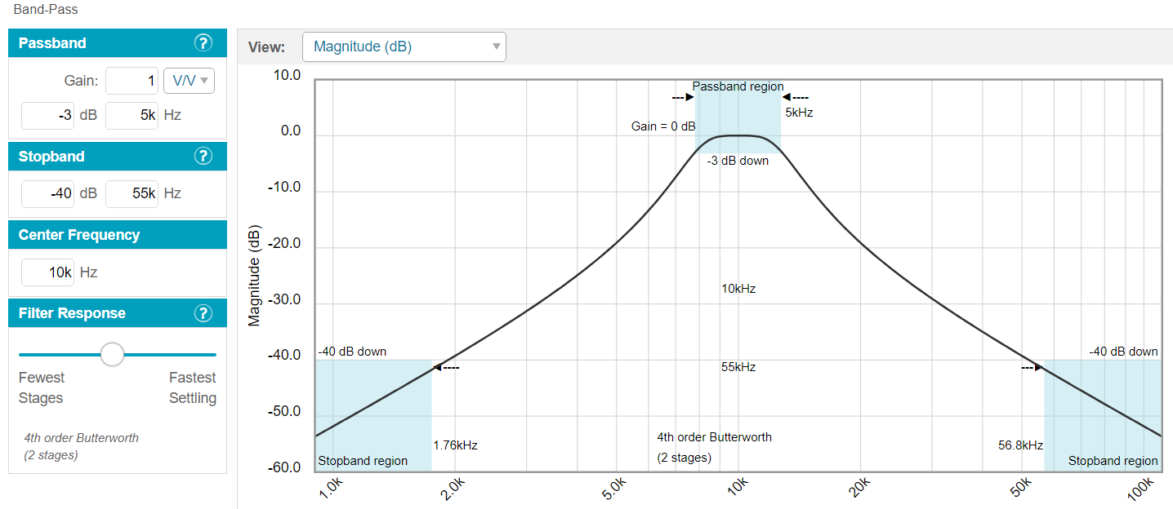

Figure 22 Design Assumptions.

To conclude we see that the design assumption matches our determined filter in the multisim application, and it is working correctly. Center frequency is found to be at 10kHz in our multisim filter. Stop band region as well as passband is also clearly visible in the figures below. For other references and descriptions of how these filters work please kindly refer to me previous report of filters in LTspice, since multisim is based on LTspice we can treat the conclusions and definitions similarly. Using cursors I seen the Fc is 10kHz , passband was 5 kHz and gain was 1V/V.

# Part 3: Homework

Below please see the filter for the Sallen-Key for audio frequencies. We will use a function generator and an oscilloscope to observe the outcome of our signals. Then we shall perform a frequency analysis of the tested filter (AC Sweep analysis) and we will be able to see if our filter works according to the predetermined design. Last of all we will compare this filter with the MFB filter and see the difference.

* Design a filter in the implementation of Sallen-Key for audio frequencies,
* Perform frequency analysis of the tested filter (AC Sweep analysis),
* Compare the determined characteristics with the design assumptions,
* Compare the filter parameters in both embodiments of the arrangement (Sallen-Key)

Below please find the Sallen Key for audio-frequencies filter:

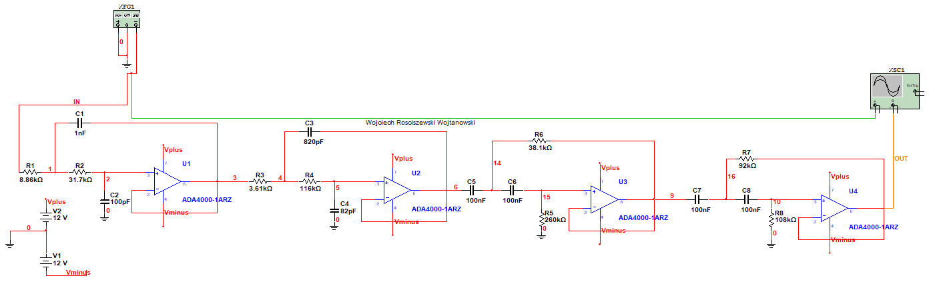

Figure 23 Sallen Key Circuit Band Pass

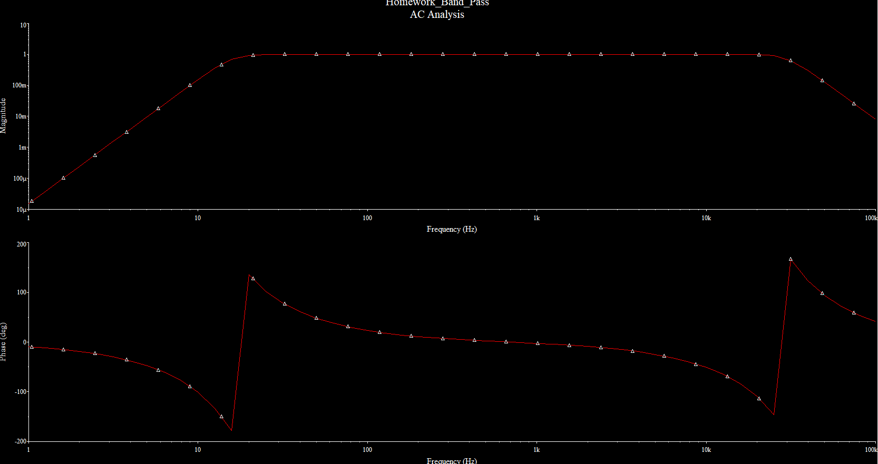

Figure AC Analysis

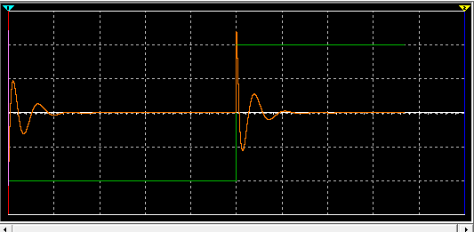

Figure 25 Oscilloscope Output

Low pass filter:

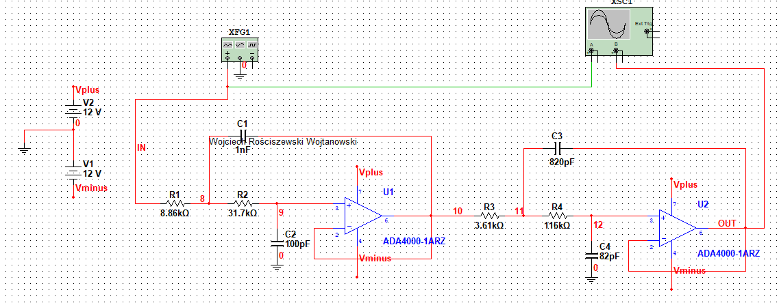

Figure 26 Low Pass Filter

Below please see the output AC analysis of this circuit:

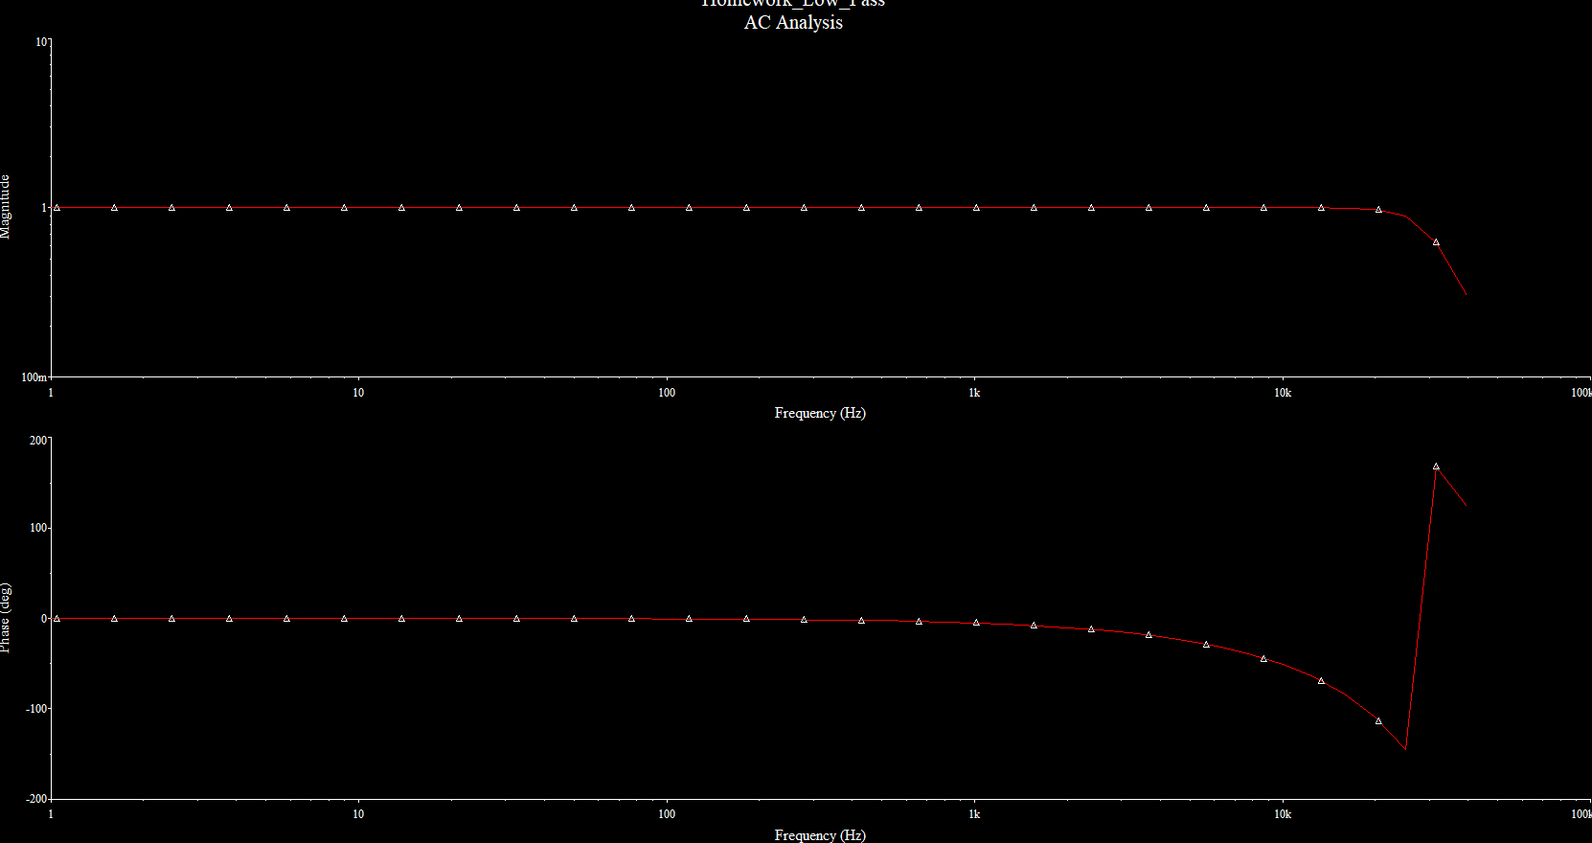

Figure 27 AC Analysis Output

With the cursors in Multisim program I was able to find that the cut-off frequency of this filter is around 21 kHz. In the figure below please see the output of the oscilloscope where we see two channels. The two channel output value characteristics are quite similar but have minor differences, which can be seen in the T1 and T2 window above the Channel and Timebase Controls.

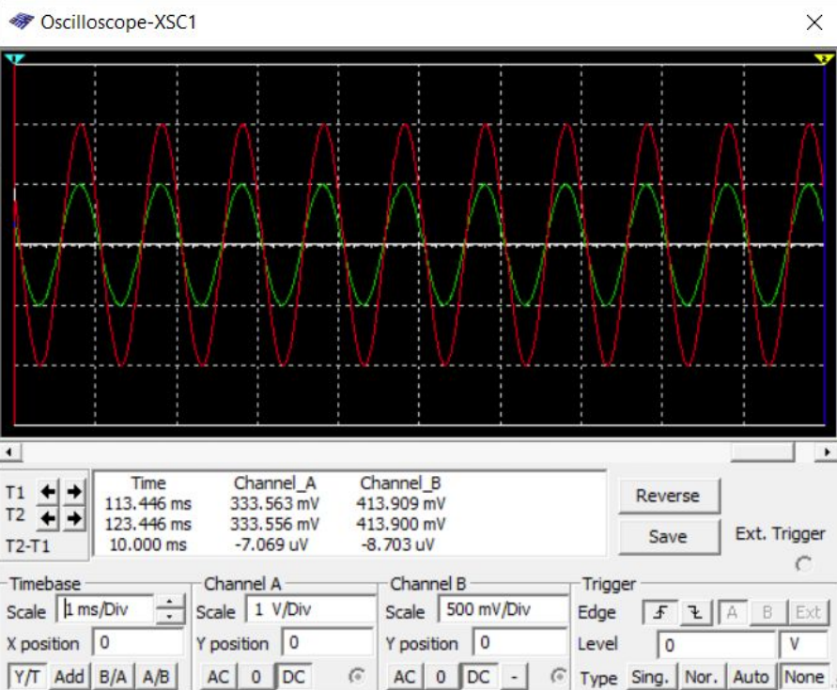

Figure Oscilloscope Output.

In the below please see the high pass filter design.

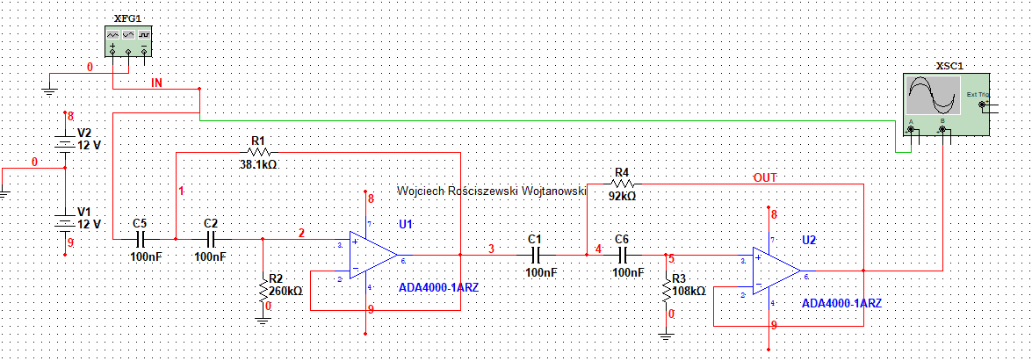

Figure 29 High Pass Filter Design

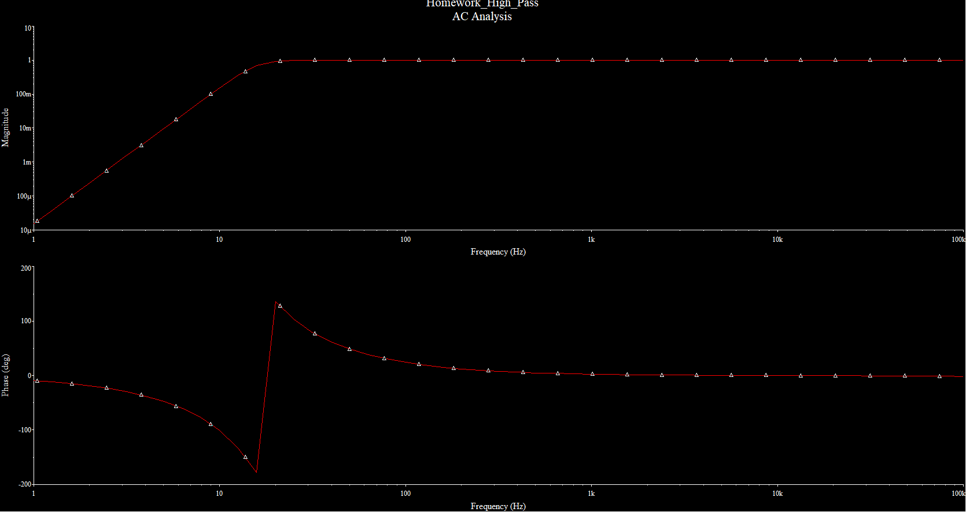

Figure AC Analysis

For Sallen Key. Conclusion is the filter works correctly, all pass-band frequencies are 21Hz to 21kHz so for the audio frequency. Rest of the filters also work as designed. All simulations have been successful for me.